**Innovation, Employability Professional Readiness for**

**and Entrepreneurship**

ASSIGNMENT 1

SMART HOME

Submitted by,

Jina J S

Reg No. 961819106027

Batch:- B12-6A2E

SMART HOME

CODE FOR SMART HOME:-

void setup()

{

pinMode(4,OUTPUT);

Serial.begin(9600);

pinMode(12,OUTPUT);

}

/*

void loop()

{

int a=analogRead(A0);

int brightness=a/4;

analogWrite(4,brightness);

}

*/

void loop()

{

int a = analogRead(A0);

Serial.print("Analog Value: ");

Serial.println(a);

int b = map(a,0,1023,0,255);

Serial.print("mapped Value: ");

Serial.println(b);

analogWrite(4,b);

double c=analogRead(A1);

double t=(((c/1024)*5)-0.5)*100;

Serial.print("TEMP VALUE: ");

Serial.println(t);

digitalWrite(12,0);

if (t>124){

digitalWrite(12,1);

}

delay(1000);

}

CIRCUIT DIAGRAM FOR SMART HOME:-

Tinker cad link: <https://www.tinkercad.com/things/cPVWxyLgyAq-smart-home>

SNAPS OF SMART HOME:-

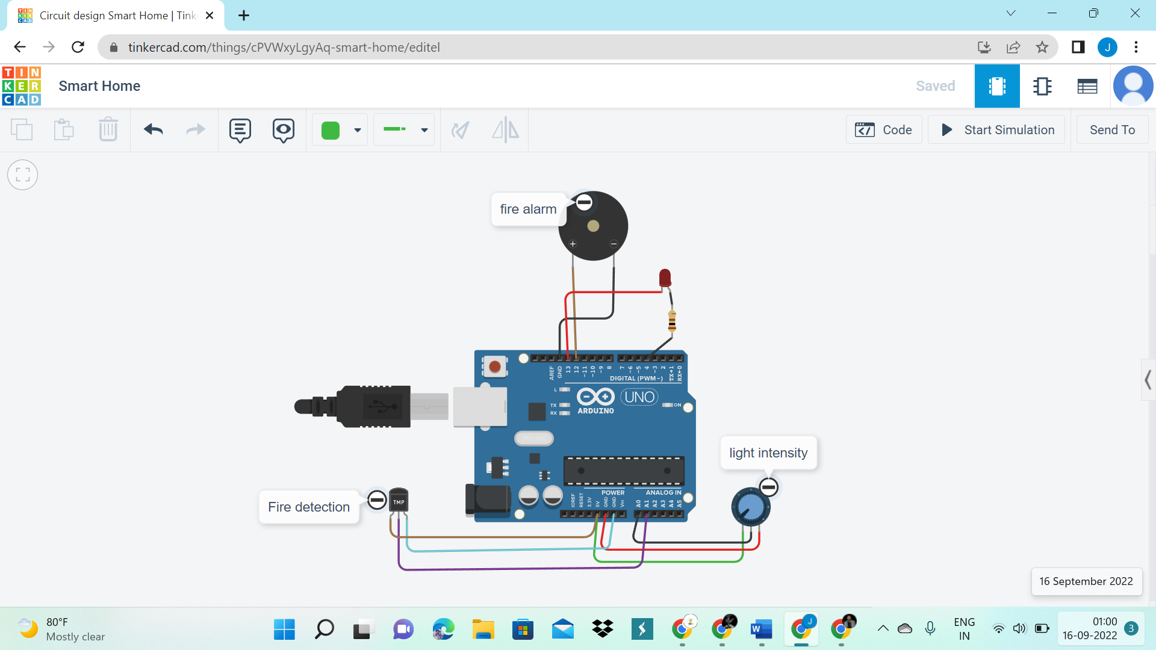

The above circuit diagram shows the smart home application where the potentiometer (pin: 0-Analog Input) is connected in a particular room to adjust the intensity of the light. In potentiometer,the intensity of the light can be increased or decreased . So the brightness level can be adjust as we wish and save power consumption.

As well as the Temperature Sensor (Pin : 1- Analog Input) in a room detects the room temperature.If the temperature in the room is above 124°C ,then the buzzer (Pin :12-Digital Output) which is connected to the temperature sensor will start to make sound which will alert people in the room to leave.